CO4 — AT2
Industry Problem Solving Task
Constraint-Based Selection of Computer Vision Methods for Real-World Deployment
Course Outcome: CO4 — Computer Vision & Object Detection Systems
Prepared with worked calculations, comparative tables, and supporting charts.

Question 1. Autonomous Vehicle Vision System Selection
Constraints:
- Accuracy must be ≥ 90% (below this → system fails)
- Latency must be ≤ 70 ms (above this → unacceptable)
- The vehicle supports only moderate computational resources
Method-by-Method Evaluation
Method | Accuracy | Latency | Computation | Accuracy ≥ 90%? | Latency ≤ 70 ms? | Verdict
Viola-Jones | 82% | 30 ms | Low | ✗ Fails | ✓ Pass | Rejected
YOLO | 93% | 60 ms | Moderate | ✓ Pass | ✓ Pass | Selected
Deep Learning | 97% | 90 ms | High | ✓ Pass | ✗ Fails | Rejected
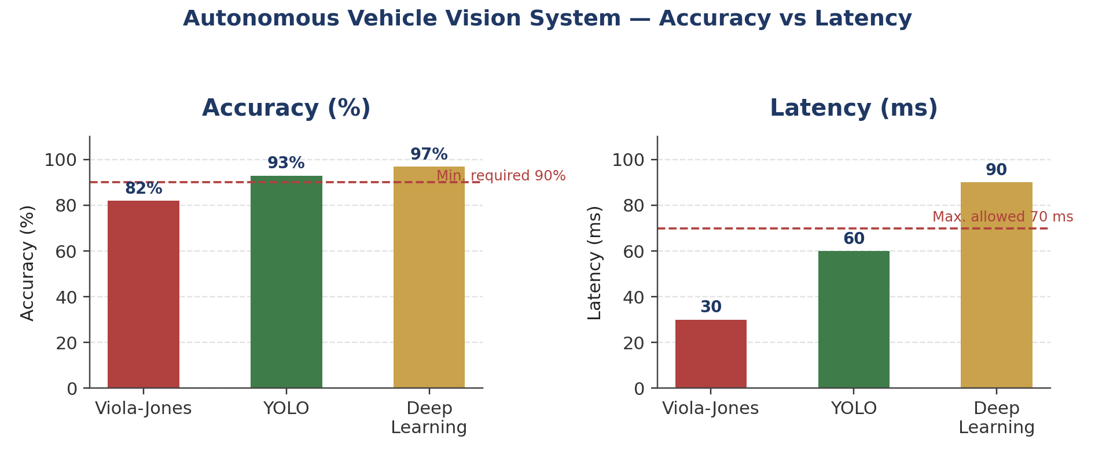
Figure 1.1 — Accuracy and latency of each method against the constraint thresholds (dashed lines).
Reasoning
Viola-Jones is fast (30 ms) and needs only low computation, but its accuracy of 82% falls below the mandatory 90% threshold — an autonomous vehicle cannot rely on a detector that is likely to miss almost 1 in 5 relevant detections, so it fails the safety constraint outright, regardless of its speed advantage.
Deep Learning achieves the highest accuracy (97%), but its latency of 90 ms exceeds the 70 ms limit and it demands high computational resources beyond what the vehicle supports. In a real-time driving context, a 90 ms delay in detecting an obstacle can translate directly into a longer stopping distance, making this option unacceptable despite its accuracy.
YOLO is the only method that satisfies all three constraints simultaneously: 93% accuracy clears the 90% minimum, 60 ms latency is within the 70 ms budget, and its moderate computational demand matches the vehicle's available resources exactly.
✔ Conclusion: YOLO is the correct choice — it is the only method that satisfies the accuracy, latency, and computational constraints at the same time, offering the best practical trade-off for real-time autonomous driving perception.

Question 2. Smart Factory Product Inspection Selection
Constraints:
- Accuracy must be ≥ 95% (below this → defects may be missed)
- Processing time must be ≤ 50 ms (above this → production line is affected)
- Hardware supports only moderate computation
Method-by-Method Evaluation
Method | Accuracy | Processing Time | Computation | Accuracy ≥ 95%? | Time ≤ 50 ms? | Verdict
Traditional Image Analysis | 91% | 25 ms | Low | ✗ Fails | ✓ Pass | Rejected
YOLO | 96% | 45 ms | Moderate | ✓ Pass | ✓ Pass | Selected
Deep Learning | 98% | 75 ms | High | ✓ Pass | ✗ Fails | Rejected
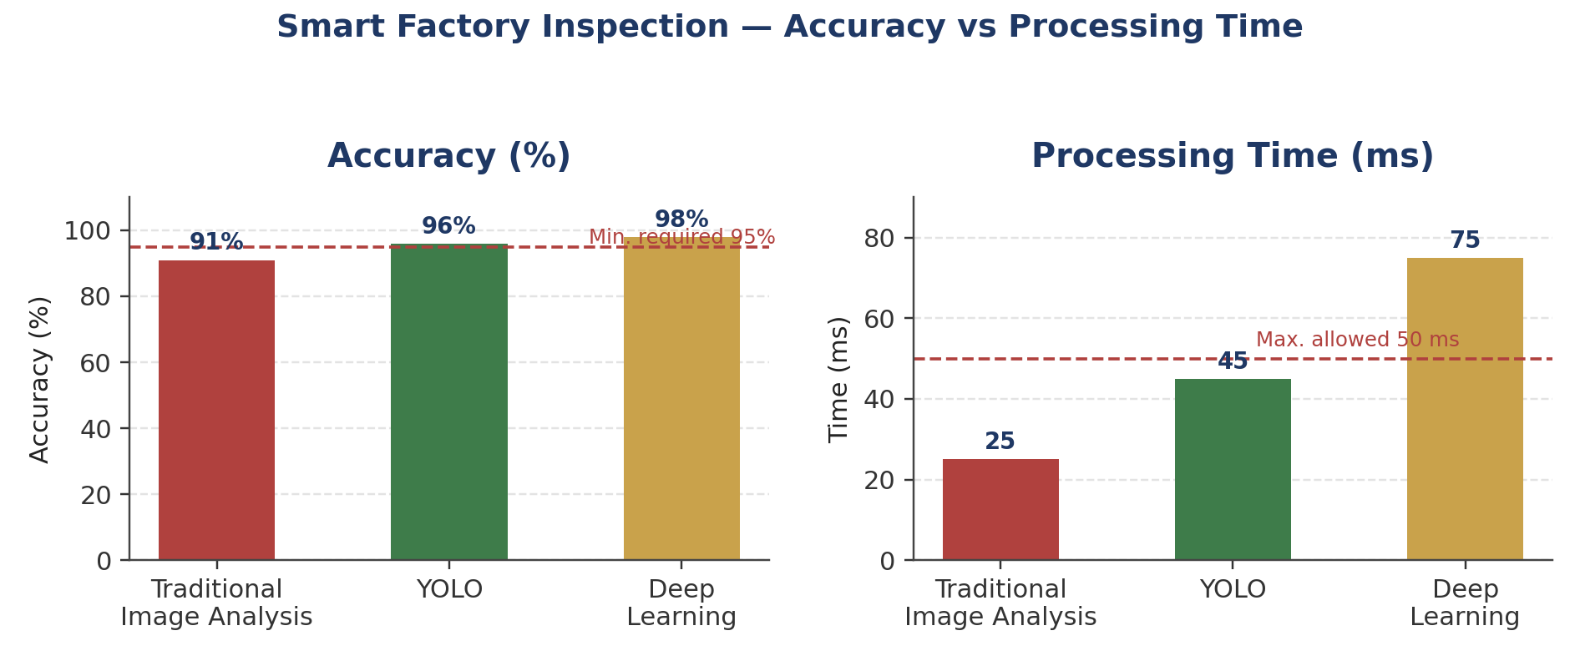
Figure 2.1 — Accuracy and processing time of each method against the constraint thresholds (dashed lines).
Reasoning
Traditional Image Analysis is fast (25 ms) and computationally light, but its 91% accuracy is below the required 95% threshold — on a production line, this means a meaningful fraction of defective products could pass inspection undetected, which is not acceptable for quality control.
Deep Learning delivers the highest accuracy (98%) but takes 75 ms per inspection, exceeding the 50 ms budget, and requires high computation that the factory's hardware does not support. At production-line speeds, this processing delay would create a bottleneck and slow the line down, defeating the purpose of real-time inspection.
YOLO again satisfies every constraint: 96% accuracy exceeds the 95% minimum, 45 ms processing time is comfortably under the 50 ms limit, and its moderate computational footprint matches the available hardware.
✔ Conclusion: YOLO is the correct choice — it meets the accuracy, processing-time, and hardware constraints together, making it the most practical method for real-time defect detection on the production line.

